
Sreenidhi Institute of Science and Technology
H.T No
Regulations:
A20
(An Autonomous Institution)
Code No: 8F494 Date:07-Feb-2025 (AN)

B.Tech II-Year II- Semester External Examination, Jan/Feb - 2025 (Supplementary)
COMPREHENSIVE TEST AND VIVA VOCE-IV (IT)

Time: 3:00 Hours Max.Marks:70
Note: Answer Any 70 Questions.
Student can solve more than 70 questions, but maximum 70 marks will be awarded.
Calculator's are not allowed.

S.No | Question
1. | The tightest lower bound on the number of comparisons in the worst case for comparison based sorting is order of?  A) n B) n² C) nlogn D) nlog²n
2. | An unordered list contains n distinct elements. The number of comparisons to find an element in this list that is neither maximum nor minimum is?  A) Θ(nlogn) B) Θ(n) C) Θ(logn) D) Θ(1)
3. | Let W(n) and A(n) denote respectively, the worst case and average case running time of an algorithm executed on an input of size n. Which of the following is always true?  a) A(n) = Ω (W(n)) b) A(n) = Θ (W(n)) c)A(n) = O (W(n)) d)A(n) = o (W(n))
4. | Consider the following segment of C-code:  int j, n;  j = 1;  while (j <= n)  j = j*2;  The number of comparisons made in the execution of the loop for any n > 0 is:  Base of Log is 2 in all options.  (A) CEIL(logn) + 2 (B) n (C) CEIL(logn) (D) FLOOR(logn) + 2
5. | Which of the following statements is false?  (A) Optimal binary search tree construction can be performed efficiently using dynamic programming.  (B) Breadth-first search cannot be used to find connected components of a graph.  (C) Given the prefix and postfix walks of a binary tree, the tree cannot be re-constructed uniquely.  (D) Depth-first-search can be used to find the connected components of a graph.
6. | What is the time complexity for arranging the one pivot element in correct position in quick sort consider worst case?  a.) O (n) b) O (n²) c.)O (n log n) d.)O(logn)
7. | Let s be a sorted array of n integers. Let t(n) denote the time taken for the most efficient algorithm to determined if there are two elements with sum less than 1000 in s. which of the following statements is true?  a) t (n) is 0 (1) b) n < t (n) < n log2n c) n log2n < t (n) d.) t(n) is o (n)
8. | You have an array of n elements. Suppose you implement quicksort by always choosing the central element of the array as the pivot. Then the tightest upper bound for the worst case performance is  (A) O(n2) (B) O(nLogn) (C) Theta(nLogn) (D) O(n3)
9. | Let w be the minimum weight among all edge weights in an undirected connected graph. Let e be a specific edge of weight w. Which of the following is FALSE?  (A) There is a minimum spanning tree containing e.  (B) If e is not in a minimum spanning tree T, then in the cycle formed by adding e to T, all edges have the same weight.  C) Every minimum spanning tree has an edge of weight w. D) e is present in every minimum spanning tree.
10. | Given items as {value,weight} pairs {{40,20},{30,10},{20,5}}. The capacity of knapsack=20. Find the maximum value output assuming items to be divisible.  a) 60 b) 80 c) 100 d) 40
11. | Which of the following is false in the case of a spanning tree of a graph G?  a) It is tree that spans G b) It is a subgraph of the G  c) It includes every vertex of the G d) It can be either cyclic or acyclic
12. | Consider a complete graph G with 4 vertices. The graph G has ____ spanning trees.  a) 15 b) 8 c) 16 d) 13
13. | What is the time complexity of TSP?  a)O(n²) b) O(nlogn) c)O(n³) d)O(n2^{n})
14. | In a given graph for n=4(no.of vertices in a graph ), how many number of binary search trees can be generated  a)11 b) 12 c)13 d)14
15. | In reliability Design , formula for the maximum no.of devices(with duplication) connected to the system at ith stage is  a ) 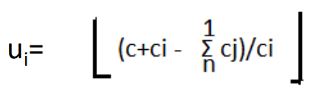 b) 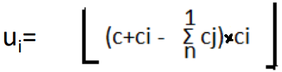 c) 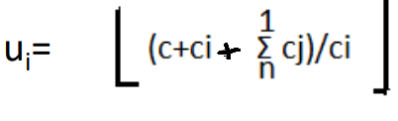 d)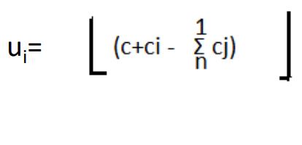
16. | For given Pair(pi,pj) and (pj,wj) Dominance Rule can be defined as  a) If (pi<=pj) and (wi<=wj) then (pi,wi) can be discarded  b) If (pi>=pj) and (wi<=wj) then (pi,wi) can be discarded  c) If (pi<=pj) and (wi>=wj) then (pi,wi) can be discarded  d) If (pi>=pj) and (wi>=wj) then (pi,wi) can be discarded
17. | Which data structure is used for implementing a LIFO branch and bound strategy?  a) stack b) queue c) array d) linked list
18. | Name the node which has been generated but none of its children nodes have been generated in state space tree of backtracking method.  a) E-Node b) Live node c) Dead Node d) Bounded node
19. | Name the node which is currently being generated  a) E-Node b) Live node c) Dead Node d) Bounded node
20. | Let G be a graph with ‘n’ nodes and let ‘m’ be the chromatic number of the graph. Then the time taken by the backtracking algorithm to color it is  a)O(nm) b) O(nmn) c)O(n+m) d)O(mn)
21. | Let S be an NP-complete problem and Q and R be two other problems not known to be in NP. Q is polynomial time reducible to S and S is polynomial-time reducible to R. Which one of the following statements is true?  a) R is NP Hard b) R is NP Complete c) S is NP Hard d) S is NP Complete
22. | Consider two decision problems Q1, Q2 such that Q1 reduces in polynomial time to 3-SAT and 3-SAT reduces in polynomial time to Q2. Then which one of the following is consistent with the above statement?  a) Q1 is in NP,Q2 is NP Hard b) Q2 is in NP,Q1 is NP Hard  c) Both Q1 and Q2 are in NP Hard d) Both Q1 and Q2are in NP
23. | The problems 3-SAT and 2-SAT are  a) Both NP Complete b) Both in P c) NP Complete and P d) Undecideble and NP Complete
24. | -5 mod -3=  a) 1 b) 2 c) 3 d) 4
25. | Software layered technology are  a) quality focus,process models,functions & non-functions  b) process models,fuctions,quality focus & planning  c)quality focus,process models,planning & modeling  d)quality focus,process models,methods & tools
26. | What is planning in S/W engineering  a) analysis, design b) delivery, design  c) estimating, scheduling & tracking d)gathering information
27. | System Software Example  a) OS,compiler design b) system stimulation c)multimedia d)word processing
28. | Embedded S/W real-time Example  a) expert system b) game playing c) spreadsheet d)microwave oven
29. | 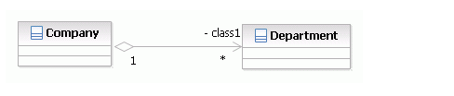  a) Aggregation b) Dependencies c) Association d) Composition
30. | 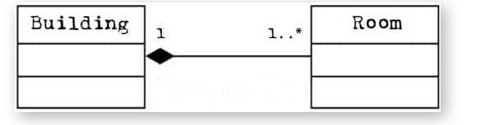  a) Aggregation b) Dependencies c) Association d) Composition
31. | Below diagram name is  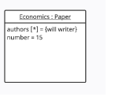a) component b) use case c) object d) sequence
32. | 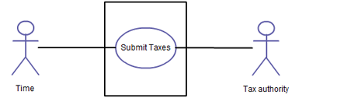  Above diagram name is  a) class b) object c) sequence d)use case
33. | Trigger transition model is  a) waterfall b)RAD c) concurrent development d)spiral
34. | NPL Stands for  a) Non-Procedural Language b) Non-performance Language  c) Network-procedural Language d) Netscape public Language
35. | Feasibility study categorize into  a) functional,non-functional & system b) technical,operational & Economic  c) functional,system & user d)technical, Non-functional & software
36. | waterfall model is also known as  a) Iterative b) NPL c) Component-based development d)classic life cycle
37. | UML relationships are  a) dependencies,generalization,association & realization  b) dependencies, generalization,extend & include  c) association,realization ,multiplicity & composition  d) association,realization,aggregation & composition
38. | Common modeling technique for Object diagram  a) workflow,operations b) links,objects  c) database sehema,logical sehema d) simple interface,collaboration
39. | Object diagram symbol is  a) 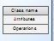 b) 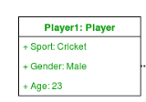 c)  d) 
40. | Actor Symbol is  a) 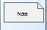 b)  c) 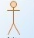 d) 
41. | Activity diagram is  a) the object that send & receice message b) flowchart message  c)activity to activity d) time-ordering of message
42. | Dependencies classifiers are  a) include,extend b) composition,aggregation c)generalization, association d)multiplicity, association
43. | 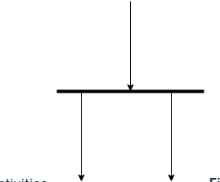  Above symbol is  a) decision b) connection c) fork d)join
44. | 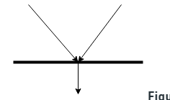  Above symbol is  a) decision b) connection c) fork d)join
45. | Component diagram common modeling techniques are  a) executables & libraries b) family’s & objects c) workflow & operations d) links & objects
46. | Deployment diagram consist of  a) class,attributes,operations b) processors,devices,connections  c) states,transitions,events d) objects,interface,collaboration
47. | State chart diagram known as  a) state machine,state transition b) static,object c) communication,interface d) state flow, state control
48. | Deployment diagram symbol is  a) 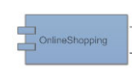 b) 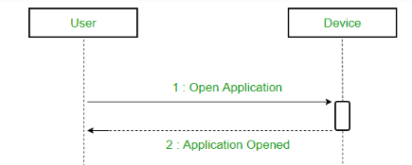 c) 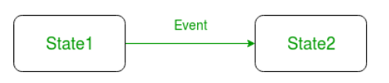 d) 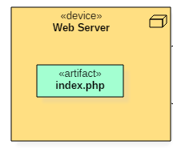
49. | Architecture of the database can be viewed as  (A) two levels. (B) four levels. (C) three levels. (D) one level.
50. | In a relational model, relations are termed as  (A)Tuples. (B) Attributes (C) Tables. (D) Rows.
51. | The database schema is written in  (A) HLL (B) DML (C) DDL (D) DCL
52. | In the architecture of a database system external level is the  (A) Physical level. (B) Logical level. (C) Conceptual level (D) view level.
53. | The database environment has all of the following components except:  (A) users. (B) separate files. (C) database. (D) database administrator.
54. | The language which has recently become the defacto standard for interfacing Application programs with relational database system is  (A) Oracle. (B) SQL. (C) DBase. (D)4GL.
55. | The way a particular application views the data from the database that the application uses is a  (A) module. (B) relational model. (C) schema. (D) sub schema.
56. | In an E-R diagram an entity set is represent by a  (A) rectangle. (B)ellipse. (C) diamond box. (D) circle.
57. | The method in which records are physically stored in a specified order according to a key field in each record is  (A)hash. (B) direct. (C) sequential. (D) all of the above.
58. | A subschema expresses  (A) the logical view. (B) the physical view. (C) the external view. (D) all of the above.
59. | Count function in SQL returns the number of  (A) values. (B) distinct values. (C) groups (D) columns.
60. | Which one of the following statements is false?  (A) The data dictionary is normally maintained by the database administrator.  (B) Data elements in the database can be modified by changing the data dictionary.  (C) The data dictionary contains the name and description of each data element.  (D) The data dictionary is a tool used exclusively by the database administrator
61. | E-R model uses this symbol to represent weak entity set ?  (A) Dotted rectangle. (B) Diamond (C) Doubly outlined rectangle (D) None of these
62. | SET concept is used in :  (A)Network Model (B) Hierarchical Model (C)Relational Model (D)None of these
63. | Relational Algebra is  (A) Data Definition Language . (B) Meta Language  (C) Procedural query Language (D)None of the above
64. | Key to represent relationship between tables is called  (A) Primary key (B) Secondary Key C) Foreign Key (D) None of these
65. | Which of the following is correct:  (A) a SQL query automatically eliminates duplicates.  (B) SQL permits attribute names to be repeated in the same relation.  (C) a SQL query will not work if there are no indexes on the relations (D) None of these
66. | It is better to use files than a DBMS when there are  (A) Stringent real-time requirements.  (B) Multiple users wish to access the data.  (C) Complex relationships among data.  (D) All of the above.
67. | The conceptual model is  (A) dependent on hardware. (B) dependent on software.  (C) dependent on both hardware and software . (D) independent of both hardware and software
68. | What is a relationship called when it is maintained between two entities?  (A) Unary (B) Binary (C) Ternary (D) Quaternary
69. | Which of the following operation is used if we are interested in only certain columns of a table?  (A) PROJECTION (B) SELECTION (C) UNION (D) JOIN
70. | Data stored in the database is processed or manipulated using data manipulation language commands as its name) ‘AS’ clause is used in SQL for  (A) Selection operation. (B) Rename operation. (C) Join operation. (D) Projection operation.
71. | (The logical implication expression A B, meaning if A then B,is equivalent to ¬A ∨ B)  The language used in application programs to request data from the DBMS is referred to as the  (A) DML (B) DDL (C) VDL (D) SDL
72. | Conceptual design  (A) is a documentation technique.  (B) needs data volume and processing frequencies to determine the size of the database.  (C) involves modelling independent of the DBMS.  (D) is designing the relational model.
73. | Perform the Subtraction 01000 - 01001 using 2’s complement method  a) 00001 b) 11111 c) 10101 d) 01010
74. | Convert the Octal number to Decimal number (237)8 = ( )10  a) 159 b) 237 c) 625 d) 259
75. | The logical sum of two or more product terms is called as  a) NAND operation b) POS c) OR operation d) SOP
76. | Convert the expression AB’C + A’BC + ABC’ to an equivalent POS  a) AB’C + A’BC + ABC’ b) (AB’C) + (A’BC) + (ABC’)  c) (A+B’+C) (A’BC) (ABC’) d) (A+B’+C) (A’+B+C) (A+B+C’)
77. | Convert a Binary number10101 to a Gray code  a ) 00010 b) 01000 c) 00101 d) 11111
78. | Convert Gray code to 10101 Binary  a ) 11001 b) 01000 c) 00101 d) 11111
79. | The Required flip-flop in T to D flip flop conversion  a ) SR flip-flop b) JK master slave c) D flip-flop d) none
80. | The Required flip-flop in JK to D flip flop conversion  a ) JK flip-flop b) SR flip-flop c) D flip-flop d) none
81. | Data in parallel form can be converted to Serial form using--- registers  a) PISO b) SISO c) SIPO d) PIPO
82. | The Propagation delay in---independent of number of flip-flops used  a) Asynchronous counter b) Synchronous counter c) trip counter d) none
83. | The shape of Normal curve is  (a) Parabola (b) Straight line (c) bell (d) Rectangle
84. | The CL’s at 99% are  (a) ±1.96 (b) ±1.65 (c) ±2.33 (d) ±2.58
85. | The test statistic for difference of 2 Proportions for large sample is z = ____________  (a) (b) (c) (d)
86. | The test statistic for paired t – test is t = __________  (a) (b) (c) (d)
87. | The relation between coefficient of correlation r and regression coefficients a and b is  (a) r = ab (b) r² = a²b² (c) r = a²+b² (d) r =
88. | The non linear regression equation of y on x is _______________  (a) y=x (b) y=a+bx (c) x=c+dy (d) y²=x
89. | The state in which a human being possesses more facilities than what are required is called  a) happiness b) prosperity c) satisfaction d) all of these
90. | The needs of the self are ensured by ______  a) right feeling b) right understanding c) both d) none
91. | Society is an extension of  a) Family b) Nature c) self d) work
92. | Conformance of human order is named as  a) right value/sanskar b) constitution conformance c) breed conformance d) seed conformance
93. | Values important for relationship are many they may include:  a)Aggression b) Competition c)Integrity and character d) Arrogance
94. | Which of the following are true with regard to safety and treatment of employees  a) It is a means of promoting worker efficiency and social order by protecting lives and promoting  the well-being of workers  b) The idea of safety and treatment of employees was conceived during the Industrial Revolution  in Europe  c) All workers have a right to expect fairness from their employer and to be treated with respect  and dignity  d) ALL
95. | In SWOT analysis Grid , what stands for S  a) Strength b) Specific c) Smart d) Sensible
96. | Failing to manage your time can lead to some consequences like  a) Less stress b) Missed deadlines c) Greater productivity d) A better Professional reputation
97. | Sentence correction  The furniture in this room are made of teak.  a) was b) is c) has d) am
98. | The decision making step, which consists of organization goals, predicting alternatives, and communicating goals is called  a)organization b) alternation c) planning d) prediction
99. | Ravi works hard to get the best student award at the end of year. What type of motivation is this?  a) Internal b) External c) immediate d) None of the above
100. | Interviews are conversations with _______  a) fun b) purpose c)friendliness d) informality

-- 00 -- 00 –

